Certificate IATF 0548789 Certificate BR12/7278

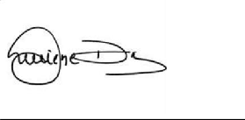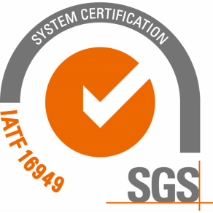

# The management system of

Usifix Indústria e Comércio de Peças para Autos Ltda.

IATF USI: C4P3GS

Rua Pedro Afonso, 81, Vila Taquari, São Paulo, SP, 08230-415, Brasil

# has been assessed and certified as meeting the requirements of

**IATF 16949:2016**

Edition 1

# For the following Scope

Manufacturing of machining and stamped parts.

**EXCLUSIONS: 8.3 Product Design**

3 Year certification is valid from 04 October 2024 until 03 October 2027 and remains valid subject to satisfactory surveillance audits.

Version no. 10. Current version updated 08 October 2024

Authorised by Luciene Dias

Veto Power Authority

Contracted Office : SGS United Kingdom Ltd, Station Road, Oldbury, B69 4LN, UK. Email : [Neil.Hall@sgs.com](mailto:Neil.Hall@sgs.com)

This document is an authentic electronic certificate for Client’ business purposes use only. Printed version of the electronic certificate are permitted and will be considered as a copy. This document is issued by the Company subject to SGS General Conditions of certification services available on [Terms and Conditions | SGS.](https://www.sgs.com/en/terms-and-conditions/) Attention is drawn to the limitation of liability, indemnification and jurisdictional clauses contained therein. This document is copyright protected and any unauthorized alteration, forgery or falsification of the content or appearance of this document is unlawful.

Page 1 / 1